**System Design and Modeling**

**T05 – Handheld Electronic Compass**

Benjamin Huntsman

Michael Walton

Cody Gabriel

John Maseda

Handheld Compass

Battery (+3.7V)

USB (+5V)

USB (data)

LCD Display

Battery (chrg.)

**Level 0**

|  |  |
| --- | --- |
| *Module* | Handheld Electronic Compass |
| *Inputs* | Battery: +3.6V  USB: +5V USB: serial data communication |
| *Outputs* | LCD Display: show heading on compass face and degrees from North Battery Charge: 100 mA constant current charge for Lithium-ion Polymer battery |
| *Functionality* | The Handheld Electronic Compass will display a compass face with directional arrow and the degrees from North, from 0 to 360 degrees. |

Magnetometer

μC

LCD

PMIC

Batt

USB (data)

USB (+5V)

+3.3V

I2C

SPI

Batt. (chrg)

Compass Display

+3.3V

**Level 1**

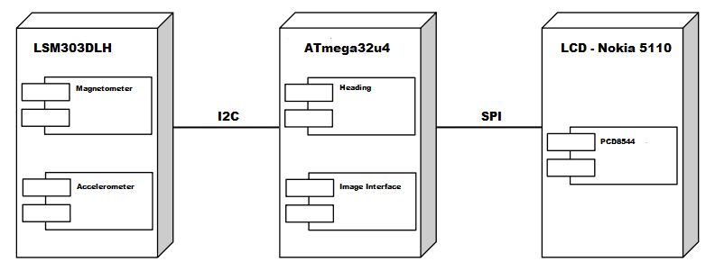

Physical View of the system.

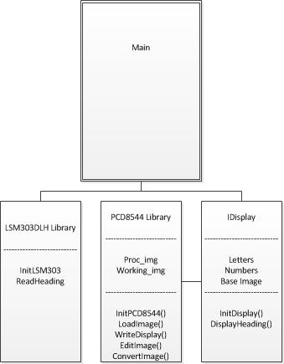

Class diagram of system.

μC

ATmega32u4

+3.3V

USB +5V

USB Data

I2C

I2C

SPI

**Level 0**

USB Data

|  |  |
| --- | --- |
| *Module* | Microcontroller: ATmega32u4 |
| *Inputs* | +3.3V: From PMIC, main power source USB +5V: From USB port USB Data: Serial interface from USB port  I2C: Serial communication with magnetometer |
| *Outputs* | I2C: Serial communication with magnetometer  SPI: Serial communication with LCD USB Data: Serial interface to USB port |
| *Functionality* | The microcontroller is the brains of the device. It establishes communication with the magnetometer and the LCD display. The μC interprets data from the magnetometer then sends it to the LCD for display. It receives power from both the PMIC and the USB port. |

+3.3V

I2C

**Magnetometer**

LSM303DLH

I2C

**Level 0**

|  |  |
| --- | --- |
| *Module* | Magnetometer: LSM303DLH |
| *Inputs* | +3.3V: From PMIC with switch controlled by μC GPIO, main power source I2C: Serial communication with microcontroller |
| *Outputs* | I2C: Serial communication with microcontroller |
| *Functionality* | The magnetometer senses the Earth’s magnetic field, and, with the aid of a built-in accelerometer, sends data to the microcontroller related to the user’s orientation and movements. Calibration on startup from microcontroller (reference to North). |

+3.3V

SPI

Heading Display

**LCD**

Nokia 5110

**Level 0**

|  |  |
| --- | --- |
| *Module* | LCD Display: Nokia 5110 |
| *Inputs* | +3.3V: From PMIC with switch controlled by μC GPIO, main power source SPI: Serial communication with microcontroller |
| *Outputs* | Heading Display: compass face and heading in degrees between and 360 |
| *Functionality* | The LCD Display outputs an image of a compass face as well as the heading in degrees from North between 0 and 360 degrees. The image comes from a library of pre-defined bitmap images stored in the μC memory. |

USB +5V

Batt. +3.7V

+3.3V

Batt. Chrg.

**PMIC**

LTC4067

**Level 0**

|  |  |
| --- | --- |
| *Module* | PMIC: LTC4067 |
| *Inputs* | USB +5V: supply from USB port, used to charge battery when connected Battery +3.7V: A lithium-ion polymer, 400 mAh, 2C battery |
| *Outputs* | +3.3V: Regulated voltage output Batt. Chrg: 100 mA regulated current to charge the LiPo battery |
| *Functionality* | The PMIC manages the power distribution by regulating the output voltage supplied to the system and charges the battery when the system is connected via USB. |